Ukulele Songbook

Vol 5

1. Carry On My Wayward Son – Kansas

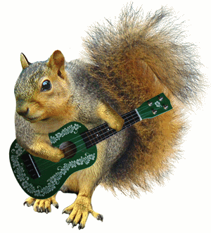3. Short Change Hero – The Heavy

5. Write Like The Wind – Paul and Storm

7. Building A Mystery – Sarah McLachlan

9. Que Sera, Sera – Doris Day

10. Come Away With Me – Norah Jones

11. Gravedigger – Dave Matthews

13. I Will Remember You – Sarah McLachlan

15. Ikea – Jonathan Coulton

17. Leather – Tori Amos

19. Re: Your Brains – Jonathan Coulton

21. Mandelbrot Set – Jonathan Coulton

24. San Andreas Fault – Natalie Merchant

25. Never Gonna Give You Up – Rick Astley

27. Possession – Sarah McLachlan

29. The Gambler – Kenny Rogers

31. Sunrise – Norah Jones

33. Free Falling – Tom Petty

35. Hallelujah – Leonard Cohen

v 1.0

**Carry On My Wayward Son – Kansas**

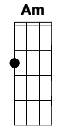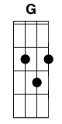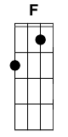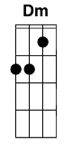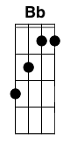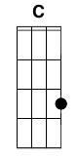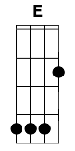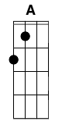

Carry on my wayward son

There'll be peace when you are done

Lay your weary head to rest

Don't you cry no more

**Am G F G**

Once I rose above the noise and confusion

**Am G F G**

Just to get a glimpse beyond this illusion

**Dm C Bb Bb C**

I was soaring ever higher

**Dm C G**

But I flew too high

**Am G F G**

Though my eyes could see I still was a blind man

**Am G F G**

Though my mind could think I still was a mad man

**Dm C Bb**

I hear the voices when I'm dreaming

**Dm C G**

I can hear them say

**Am C G F**

Carry on my wayward son,

**Am C G**

There'll be peace when you are done

**Am C G F F**

Lay your weary head to rest, don't you cry no more

**Am G F G**

Masquerading as a man with a reason

**Am G F G**

My charade is the event of the season

**Dm C Bb Bb C**

And if I claim to be a wise man

**Dm C G**

It surely means that I don't know

**Am G F G**

On a stormy sea of moving emotion

**Am G F G**

Tossed about I'm like a ship on the ocean

**Dm C Bb Bb C**

I set a course for winds of fortune

**Dm C G**

But I hear the voices say

**Am C G F**

Carry on my wayward son,

**Am C G**

There'll be peace when you are done

**Am C G F F**

Lay your weary head to rest, don't you cry no more

**Am Am**

Carry on

**G F E F G A C**

You will always remember

**Am Am**

Carry on

**G F E F G A C**

Nothing equals the splendor

**Dm C Bb Bb C**

Now your life's no longer empty

**Dm C G**

Surely Heaven waits for you

**Am C G F**

Carry on my wayward son,

**Am C G**

There'll be peace when you are done

**Am C G F F**

Lay your weary head to rest, don't you cry no more

**Short Change Hero – The Heavy**

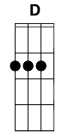

Capo 4

**Am**

I can't see where you're comin' from,

But I know just what you're runnin' from,

**G D**

And what matters ain't the who's baddest but

**Am**

The ones who stop you fallin' from your ladder.

And you feel like you're feelin' now

Doin' things just to please your crowd,

**G D**

But I love you like the way I love you,

**Am**

And I suffer, but I ain't gonna cut you cuz

Chorus:

**Am**

This ain't no place for no hero, This ain't no place for a better man,

**G D Am**

This ain't no place for no hero, to come home.

**Am**

This ain't no place for no hero, This ain't no place for a better man,

**G D Am**

This ain't no place for no hero, to come home.

Bridge:

**D Am**

And every time I close my eyes,

**D Am**

I think, I think 'bout you inside,

**D Am**

And your mother, givin' up on askin' why

**E**

Why you lie, and you cheat, and you try to make

**Am**

A fool out of she...

**Am**

I can't see where you're comin' from,

But I know just what you're runnin' from,

**G D**

And what matters ain't the who's baddest but

**Am**

The ones who stop you fallin' from your ladder.

**Am**

This ain't no place for no hero, This ain't no place for a better man,

**G D Am**

This ain't no place for no hero, to come home.

**Am**

This ain't no place for no hero, This ain't no place for a better man,

**G D Am**

This ain't no place for no hero, to come home.

**Am**

This ain't no place for no hero, This ain't no place for a better man,

**G D Am**

This ain't no place for no hero, to come home.

**Am**

This ain't no place for no hero, This ain't no place for a better man,

**G D Am**

This ain't no place for no hero, to come home.

**Write Like the Wind – Paul and Storm**

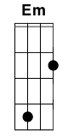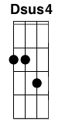

**G C G C G C G C**

**G G C G**

George R. R. Martin, please write, and write faster

**C G F D**

You're not going to get any younger, you know

**G G C G**

Winter is coming, I'm growing impatient

**C G F Am D**

And you've still got two more damn books left to go

**Am D G**

So write, George, write like the wind!

**G C G C G C G C**

**G G C G**

I curse the day that my friend ever loaned me

**C G F D**

An old dog-eared paperback called Game of Thrones

**G G C G**

How could I know that this seed would grow into

**C G D G**

An addiction that held me, right down to my bones

**Em**

Now, five books later, I lurk with the masses

**Am D**

Indignant, entitled, and waiting for word

**Em**

That the great Bearded Glacier has finally published

**Am D**

Nine hundred more pages of crack for the nerds

**Am D**

Why does every new verse of your song

**F Dsus4 D**

Keep taking you so goddamn long?

**G G C G**

George R. R. Martin, please write, and write faster

**C G F D**

Please give us boiled leather, and sigils and steel

**G G C G**

We need our allotment of incest and intrigue

**C G F Am D**

And six page descriptions of every last meal

**Am D G**

So write, George, write like the wind!

**G C G C G C G C**

**G G C G**

Lewis took five years to chronicle Narnia

**C G F D**

Tolkien had twelve years, and Rowling took ten

**G G C G**

Lucas spent nearly three decades on Star Wars

**C G D G**

And we all know how that one turned out in the end

**Em**

You're not our bitch, and you're not a machine

**Am D**

And we don't mean to dictate how you spend your days

**Em**

But please, bear in mind, in the time that you've had,

**Am D**

William Shakespeare churned out thirty-five friggin' plays

**Am D**

And if you keep writing so slow

**F Dsus4 D**

You'll hold up the HBO show

|GoT theme|

**G G Am F G C G C G C G C**

**G G C G**

George R. R. Martin, please write, and write faster

**C G F D**

Cause we won't stop whining until we're appeased

**G G C G**

Crap out the chapters and George, while you're at it

**C G F Am Dsus4 D**

Stop killing our favorite characters, please

**Am D G**

And write, George, write... like the wind!

**G C G C**

(George R.R. Martin, please write, and write faster

**G C D G**

Before you are dead, George, please write like the wind)

GoT theme:

A|--5---1-3---|

E|----3-------|

D|------------|

B|------------| x4

A|--5-----1-3-5-----1-3-0----3-----0-1-3-----1-0----|

E|-----3---------3--------------1---------1------3--|

D|--------------------------------------------------|

B|--------------------------------------------------|

**Building A Mystery – Sarah McLachlan**

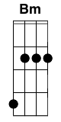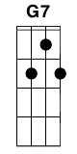

Intro: **Bm, G, D, A** (x2)

**Bm G D A**

You come out at night that's when the energy comes

**Bm G D A**

And the dark side's light and the vampires roam

**Bm G D A**

You strut your rasta wear and your suicide poem

**Bm G D A E**

And a cross from a faith that died before jesus came

**G7 G**

You're building a mystery

**Bm, G, D, A**

**Bm G D A**

You live in a church where you sleep with voodoo dolls

**Bm G D A**

And you won't give up the search for the ghosts in the halls

**Bm G D A**

You wear your sandals in the snow and a smile that won't wash away

**Bm G D A**

Can you look out the window without your shadow getting in the way

**E G**

Oh you're so beautiful with an edge and a charm

**E A**

But so careful when I’m in your arms

**Bm G D A**

'Cause you're working, building a mystery

**Bm G D A**

Holding on and holding it in

**Bm G D A**

Yeah you're working, building a mystery

**Bm G D A**

and choosing so carefully

**Bm G D A**

You woke up screaming aloud a prayer from your secret god

**Bm G D A**

and you feed off our fears and hold back your tears

**Bm G D A**

Give us a tantrum and through it all grin

**Bm G D A**

just when we need one when the evenings thin

**E G**

Oh you're a beautiful, a beautiful fucked up man

**E G**

You're setting up your razor wire shrine

**Bm G D A**

Cause you're working, building a mystery

**Bm G**

Holding on and holding it in

**Bm G D A**

Yeah you're working, building a mystery

**Bm G**

and choosing so carefully

**Bm G D**

Yeah you're working, building a mystery

**Que Sera, Sera – Doris Day**

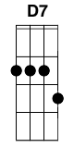

**G**

When I was just a little girl,

**Am**

I asked my mother, what will I be?

**D**

Will I be pretty, will I be rich?

**D7 G G7**

Here's what she said to me.

CHORUS:

**G7 C G**

Que Sera, Sera, whatever will be, will be.

**D D7 G D**

The future's not ours, to see. Que Sera, Sera.

**D7 G**

What will be, will be.

**G**

When I was just a child in school,

**Am**

I asked my teacher, what should I try?

**D**

Should I paint pictures? Should I sing songs?

**D7 G G**

This was her reply...

~CHORUS~

**G**

When I grew up and fell in love,

**Am**

I asked my sweetheart what lies ahead?

**D**

Will we have rainbows, day after day?

**D7 G G7**

Here's what my sweetheart said.

~CHORUS~

**G**

Now I have children of my own,

**Am**

They ask their mother, what will I be?

**D**

Will I be handsome? will I be rich?

**D7 G G7**

I tell them tenderly.

~CHORUS~ (x2)

**Come Away With Me – Norah Jones**

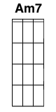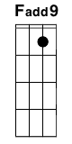

**C Am7 C Am7**

Come away with me in the night

**C Am7**

Come away with me

**Em Fadd9 C Am7**

And I will write you a song

**C Am7 C Am7**

Come away with me on a bus

**C Am7 Em Fadd9**

Come away where they can't tempt us

**C**

With their lies

**G Fadd9**

I want to walk with you

**C**

On a cloudy day

**G Fadd9 C**

In fields where the yellow grass grows knee-high

**G C**

So won't you try to come

**C Am7 C**

Come away with me and we'll kiss

**Am7**

On a mountaintop

**C Am7**

Come away with me

**Em Fadd9 C**

And I'll never stop loving you

**G Fadd9 C**

And I want to wake up with the rain

**C**

Falling on a tin roof

**G Fadd9 C**

While I'm safe there in your arms

**G C**

So all I ask is for you

**C Am7 C Am7**

To come away with me in the night

**C G C**

Come away with me

**Gravedigger – Dave Matthews**



Intro: **Am | G | E | Am G | D | Am | Am**

**Am**  **G**

Cyrus Jones, 1810 to 1913

**F**

Made his great grandchildren believe

**Am**

He could live to a hundred and three

**Am**  **G**

A hundred and three is forever when you're just a little kid

**F Am**

So Cyrus Jones lived forever

**Am**

Gravedigger

**G**

When you dig my grave

**E**

Could you make it shallow

**Am**  **G**   **D**

So that I can feel the rain

**Am Am**

Gravedigger

**Am G**

Muriel Stonewall, 1903 to 1954

**F Am**

Lost both of her babies in the second great war

**Am**

Now you should never have to watch

**G**

Your only children are lowered in the ground

**F Am**

You should never have to bury your own babies

**Am**

Gravedigger

**G**

When you dig my grave

**E**

Could you make it shallow

**Am**  **G**   **D**

So that I can feel the rain

**Am Am**

Gravedigger

**Dm F C G**

Ring around the rosey

**Dm F C G**

Pocket full of posey

**Dm F C G**

Ashes to ashes

We all fall down

**Am**

Gravedigger

**G**

When you dig my grave

**E**

Could you make it shallow

**Am**  **G**   **D**

So that I can feel the rain

**Am Am**

Gravedigger

**Am**   **G**

Little Mikey Carson, '67 to '75

**F**

He rode his

**Am**

Bike like the devil until the day he died

**Am**   **G**

When he grows up he wants to be Mr. Vertigo on the flying trapeze

**F Am**

Oh, 1940 to 1992

**Am**

Gravedigger

**G**

When you dig my grave

**E**

Could you make it shallow

**Am**  **G**   **D**

So that I can feel the rain

**Am**

Gravedigger

**G**

When you dig my grave

**E**

Could you make it shallow

**Am**  **G**   **D**

So that I can feel the rain

**Am**

I can feel the rain

**Am**

Gravedigger

**G**

When you dig my grave

**E**

Could you make it shallow

**Am**  **G**   **D**

So that I can feel the rain

**Am**

Gravedigger

**Am**

Gravedigger

**I Will Remember You – Sarah McLachlan**



Capo 2

**G D G D7**

**G C D**

I will remember you,

**G C D7**

will you remember me?

**G C G C**

Don’t let your life pass you by,

**G C D7 G**

weep not for the memories

**G C D G**

I’m so tired but I can’t sleep

**C D G**

Standing on the edge of something much too deep

**C D G D7**

It’s funny how we feel so much but we cannot say a word

**G C D7 D**

We are screaming inside, but we can’t be heard

**G C D**

I will remember you,

**G C D7**

will you remember me?

**G C G C**

Don’t let your life pass you by,

**G C D7 G**

weep not for the memories

**G C D G**

I’m so afraid to love you, but more afraid to lose

**C D C**

Clinging to a past that doesn’t let me choose

**G C D G D7**

Once there was a darkness, deep and endless night

**G C D7 G**

You gave me everything you had, oh, you gave me light

**G C D**

I will remember you,

**G C D7**

will you remember me?

**G C G C**

Don’t let your life pass you by,

**G C D7 G**

weep not for the memories

**G C D**

I will remember you,

**G C D7**

will you remember me?

**G C G C**

Don’t let your life pass you by,

**G C D7 G**

weep not for the memories

**G C D7 G**

weep not for the memories

**Ikea – Jonathan Coulton**

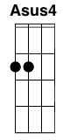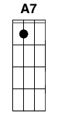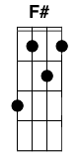

**D G A D**

Long ago in days of yore

**G A D**

It all began with a god named Thor

**A Bm**

There were Vikings and boats

**G D**

And some plans for a furniture store

**D G A D**

It's not a bodega, it's not a mall

**G A D A**

And they sell things for apartments smaller than mine

**Bm G D**

As if there were apartments smaller than mine

***A Bm G D D A Asus4***

*I-ke-a just some oak and some pine and a handful of Norsemen*

***A Bm G D D A Asus4***

*I-ke-a selling furniture for college kids and divorced men*

***G D A7 Dsus4 A7***

*Everyone has a home*

***G D A D Dsus4 D***

*But if you don't have a home you can buy one there*

**D G A D**

So rent a car or take the bus

**G A D**

Lay your cash down and put your trust

**A Bm G D**

In the land where the furniture folds to a much smaller size

**G A D**

Billy the bookcase says hello

**G A D**

And so does a table whose name is Ingo

**A Bm G D**

And the chair is a ladder-back birch but his friends call him Karl

***A Bm G D D A Asus4***

*I-ke-a just some oak and some pine and a handful of Norsemen*

***A Bm G D D A Asus4***

*I-ke-a selling furniture for college kids and divorced men*

***G D A7 Dsus4 A7***

*Everyone has a home*

***G D A D Dsus4 D***

*But if you don't have a home you can buy one there*

**Bm F#**

Ikea: plywood, brushed steel

**D A7 D**

Ikea: meatballs, tasty

**Bm F#**

Ikea: Allen wrenches

**D**

All of them for free

**F#**

All of them for me

Uke Solo

------------|----------7--|--------------------|-------------|

------------|-------------|5-------------------|------5----5-|

-4-6--4-2---|2-4-6--4-2---|--------------------|-------------|

----------4-|-----------7-|---4-7--9--9--11--9-|7--4----4----|

------------|----------------|---------------------|

-5---5---5--|-3-3--3---------|3-5-5-3-5-5-3-5-5-5-5|

4--6---4--6-|-2-2--2-6--4-2--|--2-2---2-2---2-2-2-2|

------------|----------------|5-----5-----5--------|

**D G A D**

I'm sorry I said Ikea sucks

**G A D**

I just bought a table for sixteen bucks

**A Bm G D**

And a chair and a lamp And a shelf and some candles for you

**G A D**

I was a doubter just like you

**G A D**

'til I saw the American dream come true

**A Bm G D**

In New Jersey, they got a god damned Swedish parade

***A Bm G D D A Asus4***

*I-ke-a just some oak and some pine and a handful of Norsemen*

***A Bm G D D A Asus4***

*I-ke-a selling furniture for college kids and divorced men*

***G D A7 Dsus4 A7***

*Everyone has a home*

***G D A D Dsus4 D***

*But if you don't have a home you can buy one there*

**Leather – Tori Amos**

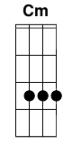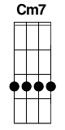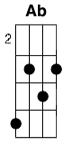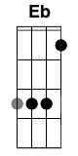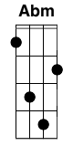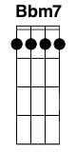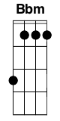

**Cm G Cm7 F**

Look I'm standing naked before you

**Ab Eb D G**

Don't you want more than my sex

**Cm G Cm7 F**

I can scream as loud as your last one

**Ab Eb D G**

But I can't claim innocence

**Abm Eb Abm Bbm7**

Oh god ... could it be the weather

**Abm Eb Bsus2 F#**

Oh god ... why am I here

**Abm Eb Abm Bbm7**

If love isn't forever

**Gb7 Eb**

And It’s not the weather

**Abm Bbm**

Hand me my leather

**Cm G Cm7 F**

I could just pretend that you love me

**Ab Eb D G**

The night would lose all sense of fear

**Cm G Cm7 F**

But why do I need you to love me

**Ab Eb D G**

When you can't hold what I hold dear

**Abm Eb Abm Bbm7**

Oh god ... could it be the weather

**Abm Eb Bsus2 F#**

Oh god ... why am I here

**Abm Eb Abm Bbm7**

If love isn't forever

**Gb7 Eb**

And It’s not the weather

**Abm Bbm**

Hand me my leather

**Cm G Cm7 F**

I almost ran over an angel

He had a nice big fat cigar

**Cm G Cm7 F**

In a sense he said you're alone here

So if you jump you best jump far

**Abm Eb Abm Bbm7**

Oh god ... could it be the weather

**Abm Eb Bsus2 F#**

Oh god ... why am I here

**Abm Eb Abm Bbm7**

If love isn't forever

**Gb7 Eb**

And It’s not the weather

**Abm Bbm**

Hand me my leather

**Abm Eb Abm Bbm7**

Oh god ... could it be the weather

**Abm Eb Bsus2 F#**

Oh god ... it’s all very clear

**Abm Eb Abm Bbm7**

If love isn't forever

**Gb7 Eb**

And It’s not the weather

**Abm Bbm**

Hand me my leather

**Re: Your Brains – JoCo**

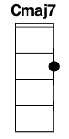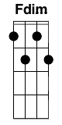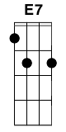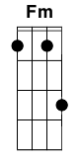**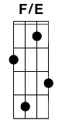****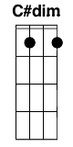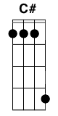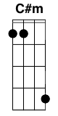**

**Am F C C Cmaj7**

Heya Tom, it’s Bob.. from the office down the hall

**Am F G**

Good to see you buddy, how’ve you been?

**Fdim Am Am7 D7**

Things have been OK for me except that I’m a zombie now

**G**

I really wish you’d let us in

**F C E7 Am**

I think I speak for all of us when I say I understand

**F C E7 Am**

Why you folks might hesitate to submit to our demand

**F Fm**

But here’s an FYI: you’re all gonna die screaming

**C G F G**

All we want to do is eat your brains

**C G F**

We’re not unreasonable, I mean, no-one’s gonna eat your eyes

**(F/E F F/E F) G**

**C G F G**

All we want to do is eat your brains

**Am Em F (F/E F F/E F F/E)**

We’re at an impasse here, maybe we should compromise:

**F F/E Dm**

If you open up the doors

**F F/E F G C**

We’ll all come inside and eat your brains

**Am F C C Cmaj7**

I don’t want to nitpick, Tom, but is this really your plan?

**Am F G**

To spend your whole life locked inside a mall?

**Fdim Am Am7 D7**

Maybe that’s OK for now but someday you’ll be out of food and guns

**G**

And then you’ll have to make the call

**F C E7 Am**

I’m not surprised to see you haven’t thought it through enough

**F C E7 Am**

You never had the head for all that bigger picture stuff

**F**  **Fm**

But Tom, that’s what I do, and I plan on eating you slowly

**C G F G**

All we want to do is eat your brains

**C G F (F/E F F/E F) G**

We’re not unreasonable, I mean, no-one’s gonna eat your eyes

**C G F G**

All we want to do is eat your brains

**Am Em F (F/E F F/E F F/E)**

We’re at an impasse here, maybe we should compromise:

**F F/E Dm**

If you open up the doors

**F F/E F G Ab**

We’ll all come inside and eat your brains

**Eb C#dim C#**

I’d like to help you Tom, in any way I can

**C#m Ab**

I sure appreciate the way you’re working with me

**Eb C#dim Fm**

I’m not a monster Tom, well, technically I am

**C**

I guess I am

**Am F C C Cmaj7**

I’ve got another meeting Tom, maybe we could wrap it up

**Am F G**

I know we’ll get to common ground somehow

**Fdim Am Am7 D7**

Meanwhile I’ll report back to my colleagues who were chewing on the doors

**G**

I guess we’ll table this for now

**F C E7 Am**

I’m glad to see you take constructive criticism well

**F C E7 Am**

Thank you for your time I know we’re all busy as hell

**F Fm**

And we’ll put this thing to bed when I bash your head open

**C G F G**

All we want to do is eat your brains

**C G F**

We’re not unreasonable, I mean, no-one’s gonna eat your eyes

**(F/E F F/E F) G**

**C G F G**

All we want to do is eat your brains

**Am Em F (F/E F F/E F F/E)**

We’re at an impasse here, maybe we should compromise:

**F F/E Dm**

If you open up the doors

**F F/E F G C**

We’ll all come inside and eat your brains

**Mandelbrot Set – Jonathan Coulton**

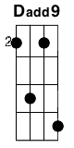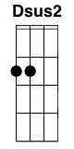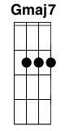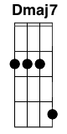

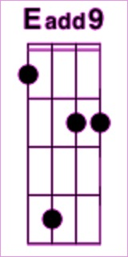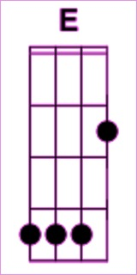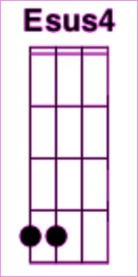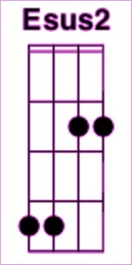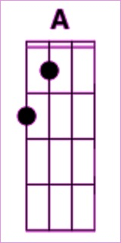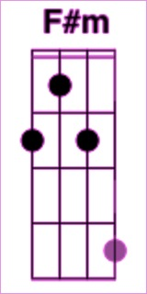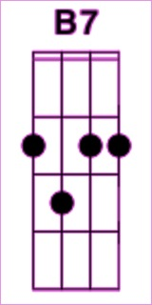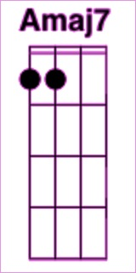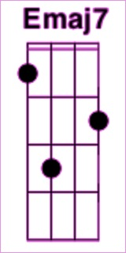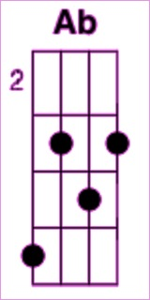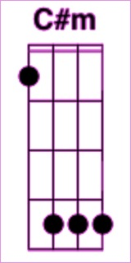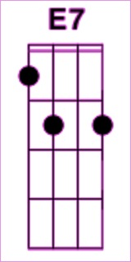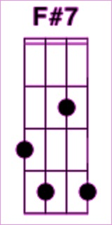

**Capo 2(no capo)**

**DE** Riff: **Dadd9Eadd9 DE Dsus4Esus4 DE**

Intro: **Dsus2Esus2 DE DE Dsus4Esus4 DE Dsus2Esus2 DE**

**DE**(riff) **GA** **EmF#m**

Pathological monsters! cried the terrified mathematician

**GA** **A7B7** **DE**

Every one of them is a splinter in my eye

**DE**

I hate the Peano Space and the Koch Curve

**GA** **EmF#m**

I fear the Cantor Ternary Set

**GA** **A7B7** **DE**

The Sierpinski Gasket makes me want to cry

**Gmaj7Amaj7** **Dmaj7Emaj7Gmaj7Amaj7Dmaj7Emaj7**

And a million miles away a butterfly flapped its wings

**Gmaj7Amaj7** **Dmaj7Emaj7EmF#m** **A7B7 DE**(riff)2x

On a cold November day.. a man named Benoit Mandelbrot was born

**DE**(riff) **GA** **EmF#m**

His disdain for pure mathematics and his unique geometrical insights

**GA** **A7B7** **DE**(riff)

Left him well equipped to face those demons down

**DE** **GA** **EmF#m**

He saw that infinite complexity could be described by simple rules

**GA** **AB** **DE**

He used his giant brain to turn the game around

**Gmaj7Amaj7** **Dmaj7Emaj7**

And he looked below the storm and saw a vision in his head

**Gmaj7Amaj7** **Dmaj7Emaj7**

A bulbous pointy form

**EmF#m** **AB** **DE** **A7B7DE** **A7B7**

He picked his pencil up and he wrote his secret down

**DE** **A7B7** **DE** **A7B7**

Take a point called C in the complex plane

**DE** **A7B7** **DE** **A7B7**

Let Z1 be Z squared plus C

**DE** **A7B7** **DE** **A7B7**

And Z2 is Z1 squared plus C

**DE** **A7B7** **DE** (break)

And Z3 is Z2 squared plus C and so on

**GA** **A7B7**

If the series of Z's should always stay

**F#Ab** **BmC#m** **AB**

Close to C and never trend away

**GA** **A7B7** **DE**(break)

That point is in the Mandelbrot Set

**A7B7**

Mandelbrot Set you're a Rorschach Test on fire

**DE**

You're a day-glo pterodactyl

**A7B7**

You're a heart-shaped box of springs and wire

**DE** **D7E7**

You're one badass fucking fractal

**E7F#7** **Gmaj7Amaj7**

And you're just in time to save the day

**E7F#7 Gmaj7Amaj7**

Sweeping all our fears away

**E7F#7 Gmaj7Amaj7** **DE**(riff)4x

You can change the world in a tiny way

**DE** (hold) **GA** **EmF#m**

Mandelbrot's in heaven, at least he will be when he's dead

**GA** **A7B7** **DE**(riff)

Right now he's still alive and teaching math at Yale

**DE**(riff) **GA** **EmF#m**

He gave us order out of chaos, he gave us hope where there was none

**GA** **A7B7** **DE**

And his geometry succeeds where others fail

**Gmaj7Amaj7** **Dmaj7Emaj7Gmaj7Amaj7** **Dmaj7Emaj7**

If you ever lose your way, a butterfly will flap its wings

**Gmaj7Amaj7** **Dmaj7Emaj7 EmF#m** **A7B7** **DE**

From a million miles away, a little miracle will come to take you home

**A7B7** **DE** **A7B7**

**DE** **A7B7** **DE** **A7B7**

Take a point called C in the complex plane

**DE** **A7B7** **DE** **A7B7**

Let Z1 be Z squared plus C

**DE** **A7B7** **DE** **A7B7**

And Z2 is Z1 squared plus C

**DE** **A7B7** **DE** (break)

And Z3 is Z2 squared plus C and so on

**GA** **A7B7**

If the series of Z's should always stay

**F#Ab** **BmC#m** **AB**

Close to C and never trend away

**GA** **A7B7** **DE**(break)

That point is in the Mandelbrot Set

**A7B7**

Mandelbrot Set you're a Rorschach Test on fire

**DE**

You're a day-glo pterodactyl

**A7B7**

You're a heart-shaped box of springs and wire

**DE** **D7E7**

You're one badass fucking fractal

**E7F#7** **Gmaj7Amaj7**

And you're just in time to save the day

**E7F#7** **Gmaj7Amaj7**

Sweeping all our fears away

**E7F#7** **Gmaj7Amaj7 DE**(riff)

You can change the world in a tiny way

**E7F#7** **Gmaj7Amaj7**

And you're just in time to save the day

**E7F#7** **Gmaj7Amaj7**

Sweeping all our fears away

**E7F#7** **Gmaj7Amaj7**

You can change the world in a tiny way

**E7F#7** **Gmaj7Amaj7**

Go on change the world in a tiny way

**E7F#7** **Gmaj7Amaj7**

Come on change the world in a tiny way

**San Andreas Fault - Natalie Merchant**



Capo 1

Intro: **C G Am Em** x2

**C G Am**

Go west paradise is there you'll have all that you can eat

**Em**

Of milk & honey over there

**C G**

You'll be the brightest star the world has ever seen

**Am Em**

Sun-baked slender heroine of film & magazine

**C G Am Em**

**C G Am**

Go west paradise is there you'll have all that you can eat

**Em**

Of milk & honey over there

**C G**

You'll be the brightest light the world has ever seen

**Am**  **Em**

The dizzy height of a jet-set life you could never dream

**C G D Em**

Your pale blue eyes, strawberry hair, lips so sweet, skin so fair

**C G D Em**

Your future bright, beyond compare, it's rags to riches, over there

**C G Am Em** x2

**C G**

San Andreas fault moved its fingers through the ground

**Am Em**

Earth divided plates collided such an awful sound

**C G**

San Andreas fault moved its fingers through the ground

**Am Em**

Terra cotta shattered and the walls came tumbling down

**C G D Em**

O, promised land O, wicked ground, build a dream tear it down

**C G D Em**

O, promised land, what a wicked ground, build a dream, watch it all fall down

**C G Am Em** x3

**Never Gonna Give You Up – Rick Astley**

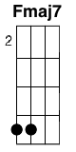

Intro: **Fmaj7 G Em Am**

**Fmaj7 G**

We're no strangers to love

**Fmaj7 G**

You know the rules and so do I

**Fmaj7 G**

A full commitment's what I'm thinking of

**Fmaj7 G**

You wouldn't get this from any other guy

**F G**

I just wanna tell you how I'm feeling

**F G**

Gotta make you understand

**Fmaj7 G**

Never gonna give you up

**Em Am**

Never gonna let you down

**Fmaj7 G Em Am**

Never gonna run around and desert you

**Fmaj7 G**

Never gonna make you cry

**Em Am**

Never gonna say goodbye

**Fmaj7 G Em Am**

Never gonna tell a lie and hurt you

**Fmaj7 G**

We've know each other for so long

**Fmaj7 G**

Your heart's been aching

**Fmaj7 G**

But you're too shy to say it

**Fmaj7 G**

Inside we both know what's been going on

**Fmaj7 G**

We know the game and we're gonna play it

**F G**

And if you ask me how I'm feeling

**F G**

Don't tell me you're too blind to see

*Chorus x2*

Bridge

**Fmaj7 G G G**

(Ooohh give you up)

**Fmaj7 G G G**

(Ooohh give you up)

**Fmaj7**

Never gonna give

**Fmaj7 G G G**

Never gonna give, (give you up)

**Fmaj7**

Never gonna give

**Fmaj7 G G G**

Never gonna give, (give you up)

Verse 2

Prechorus

Chorus x3 (Third time fade out)

**Possession – Sarah McLachlan**

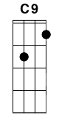

Capo 2

**Am**

Listen as the wind blows

**G D Dsus**

from across the great divide.

**Am**

Voices trapped in yearning

**G D Dsus**

memories trapped in time

**Am**

the night is my companion

**G D Dsus**

and solitude my guide

**F Am**

would I spend forever here

**Dsus D**

and not be satisfied.

**F Am**

And I would be the one

**Cmaj9**

to hold you down

**F**

kiss you so hard

**Dm Am F**

I'll take your breath away,

**Am**

and after I'd

**Cmaj9**

wipe away the tears

**Dm Em Am**

just close your eyes dear.

**Am**

Through this would I've stumbled

**G D Dsus**

so many times betrayed

**Am**

trying to find an honest word to find

**G D Dsus**

the truth enslaved,

**Am**

oh you speak to me in riddles

**G D Dsus**

and you speak to me in rhyme

**Am**

my body aches to breathe your breath

**G D Dsus**

your words keep me alive

**F Am**

And I would be the one

**Cmaj9**

to hold you down

**F**

kiss you so hard

**Dm Am F**

I'll take your breath away,

**Am**

and after I'd

**Cmaj9**

wipe away the tears

**Dm Em Am**

just close your eyes dear.

**Am**

Into this night I wander

**G D Dsus**

it's morning that I dread

**Am**

another day of knowing of

**G D Dsus**

the path I fear to tread

**Am**

on into the sea of waking dreams

**G D Dsus**

I follow without pride

**F Am**

nothing stands between us here

**D**

and I won't be denied.

**F Am**

And I would be the one

**Cmaj9**

to hold you down

**F**

kiss you so hard

**Dm Am F**

I'll take your breath away,

**Am**

and after I'd

**Cmaj9**

wipe away the tears

**Dm Em Am**

just close your eyes...

**The Gambler – Kenny Rogers**

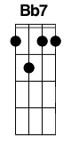

**D G D**

On a warm summer's evenin' on a train bound for nowhere,

**D A7**

I met up with the gambler; we were both too tired to sleep.

**D G D**

So we took turns a starin' out the window at the darkness

**A7 D**

'til boredom overtook us, and he began to speak.

**D G D**

He said, "Son, I've made a life out of readin' people's faces,

**A7**

and knowin' what their cards were by the way they held their eyes.

**D G D**

And if you don't mind my sayin', I can see you're out of aces.

**G D A7 D**

For a taste of your whiskey I'll give you some advice."

**D G D**

So I handed him my bottle and he drank down my last swallow.

**A7**

Then he bummed a cigarette and asked me for a light.

**D G D**

And the night got deathly quiet, and his face lost all expression.

**G D A7 D**

Said, "If you're gonna play the game, boy, ya gotta learn to play it right.

Chorus:

**D G D**

You got to know when to hold 'em, know when to fold 'em,

**G D A7**

know when to walk away and know when to run.

**D G D G D**

You never count your money when you're sittin' at the table.

**D G D A7 D**

There'll be time enough for countin' when the dealin's done.

*(Key change (No change in RED))*

**EbD AbG EbD**

Ev'ry gambler knows that the secret to survivin'

**Bb7A7**

is knowin' what to throw away and knowing what to keep.

**Eb Ab Eb**

'Cause ev'ry hand's a winner and ev'ry hand's a loser,

**Ab Eb Bb7 Eb**

and the best that you can hope for is to die in your sleep."

Verse 5:

**Eb Ab Eb**

And when he'd finished speakin', he turned back towards the window,

**Bb7**

crushed out his cigarette and faded off to sleep.

**Eb Ab Eb**

And somewhere in the darkness the gambler, he broke even.

**Ab Eb Bb7 Eb**

But in his final words I found an ace that I could keep.

Chorus:

**Eb Ab Eb**

You got to know when to hold 'em, know when to fold 'em,

**Ab Eb Bb7**

know when to walk away and know when to run.

**Eb Ab Eb Ab Eb**

You never count your money when you're sittin' at the table.

**Eb Ab Eb Bb7 Eb**

There'll be time enough for countin' when the dealin's done.

~A cappella chorus~

~Chorus~

**Sunrise – Norah Jones**

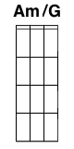

(Capo 3)

Intro:

**Am/G G C**

**Am/G G C**

**Am/G G C F**

**G Am/G**

Sunrise, sunrise

**G C**

Looks like mornin' in your eyes

**Am/G F C**

But the clocks held 9:15 for hours

**G Am/G**

Sunrise, sunrise

**G C**

Couldn't tempt us if it tried

**Am/G F C**

'Cause the afternoon's already come and gone

**Am/G G C F** (x3)

And I said hoo...

**Dm**

To you

**G Am/G**

Surprise, surprise

**G C**

Couldn't find it in your eyes

**Am/G F C**

But I'm sure it's written all over my face

**G Am/G**

Surprise, surprise

**G C**

Never something I could hide

**Am/G F C**

When I see we made it through another day

**Am/G G C F** (x3)

And I said hoo...

**Dm**

To you

Bridge:

**G Am/G G C Am/G F C** (2x)

**Dm F**

Now good night

**Dm**

Throw its cover down

**F**

Ooh on me again

**Dm F**

Ooh and if I'm right

**Dm**

It's the only way

**F**

To bring me back

**Am/G G C F** (x3)

Hoo...

**Dm**

To you

**Am/G G C F** (x3) **C**

Hoo...

**Free Falling – Tom Petty**



Intro: **D Dsus4 Dsus4 D A** x2

**D Dsus4 Dsus4 D A**

She s a good girl, loves her mama

**D Dsus4 Dsus4 D A**

loves Je-sus and America too

**D Dsus4 Dsus4 D A**

she s a good girl, crazy about Elvis

**D Dsus4 Dsus4 D A**

loves hors-es and her boy friend too

**D Dsus4 Dsus4 D A**

**D Dsus4 Dsus4 D A**

It s a long day living in Reseda

**D Dsus4 Dsus4 D A**

there s a free-way running through the yard

**D Dsus4 Dsus4 D A**

and I m a bad boy, cause I don t even miss her

**D Dsus4 Dsus4 D A**

I m a bad boy for breaking her heart

**D Dsus4 Dsus4 D A D Dsus4 Dsus4 D A**

Now I m free free fall-ing

**D Dsus4 Dsus4 D A D Dsus4 Dsus4 D A**

Now I m free free fall-ing

**D Dsus4 Dsus4 D A**

All the vampires walking through the valley

**D Dsus4 Dsus4 D A**

move west down Ventura Boulevard

**D Dsus4 Dsus4 D A**

all the bad boys are standing in the shadows

**D Dsus4 Dsus4 D A**

and the good girls are home with broken hearts

**D Dsus4 Dsus4 D A D Dsus4 Dsus4 D A**

Now I m free free fall-ing

**D Dsus4 Dsus4 D A D Dsus4 Dsus4 D A**

Now I m free free fall-ing

**D Dsus4 D A**

Free falling now I m free falling

**D Dsus4 D A**

Free falling now I m free falling

**D Dsus4 Dsus4 D A**

I wanna glide down over Mulholland

**D Dsus4 Dsus4 D A**

I wanna write her name in the sky

**D Dsus4 Dsus4 D A**

gonna free fall out into nothing

**D Dsus4 Dsus4 D A**

gonna leave this world for a while

**D Dsus4 Dsus4 D A D Dsus4 Dsus4 D A**

Now I m free free fall-ing

**D Dsus4 Dsus4 D A D Dsus4 Dsus4 D A**

Yeah I m free free fall-ing (x4)

**Hallelujah – Leonard Cohen**



Intro: **C Am C Am**

**C Am**

Now I've heard there was a secret chord,

**C Am**

that David played, and it pleased the Lord

**F G C G**

But you don't really care for music, do you?

**C F G**

It goes like this the fourth, the fifth,

**Am F**

the minor fall, the major lift

**G Em Am**

The baffled king composing Hallelujah

**F**

Hallelujah

**Am**

Hallelujah

**F**

Hallelujah

**C G C G**

Hallelu jah

**C Am**

Your faith was strong but you needed proof,

**C Am**

you saw her bathing on the roof

**F G C G**

Her beauty and the moonlight overthrew you

**C F G**

She tied you to a kitchen chair,

**Am F**

she broke your throne, and she cut your hair

**G Em Am**

And from your lips she drew the Hallelujah

***~Chorus~***

**C Am**

Now, maybe there's a God above,

**C Am**

and all I ever learned from love,

**F G C G**

was how to shoot at someone who outdrew you

**C F G**

It's not a cry you can hear at night,

**Am F**

it's not somebody who's seen the light,

**G Em Am**

it's a cold and it's a broken Hallelujah

***~Chorus~***

**C Am**

Oh, people, I ve been here before,

**C Am**

I know this room, I've walked this floor

**F G C G**

I used to live alone before I knew you.

**C F G**

I've seen your flag on the marble arch

**Am F**

Love is not a victory march

**G Em Am**

it's a cold and it's a broken Hallelujah

***~Chorus~***

**C Am**

There was a time you let me know,

**C Am**

what's really going on below

**F G C G**

But now you never show it to me, do you?

**C F G**

And remember when I moved in you

**Am F**

The holy dove was moving too

**G Em Am**

And every breath we drew was Hallelujah

***~Chorus~***

**C Am**

I ve done my best, it wasn't much,

**C Am**

I couldn't feel, so I learned to touch

**F G C G**

I've told the truth, I didn't come to fool you

**C F G**

And even though it all went wrong

**Am F**

I'll stand before the Lord of Song

**G Em Am**

With nothing on my tongue but Hallelujah

***~Chorus 2x~***Chords – GCEA (Standard) Tuning

Maj/Minor

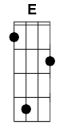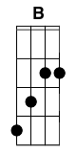

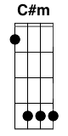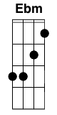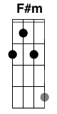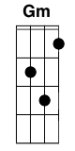

7

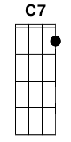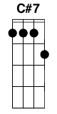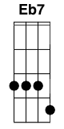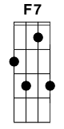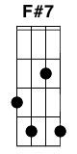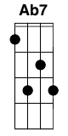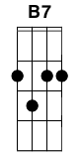

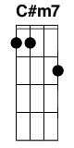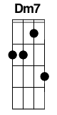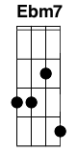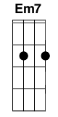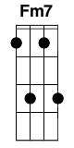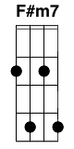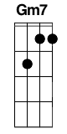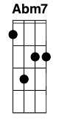****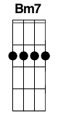

Maj

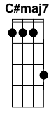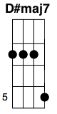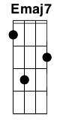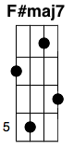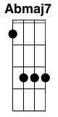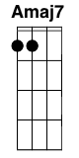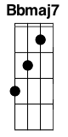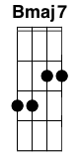

Sus

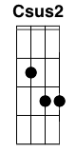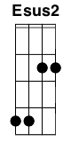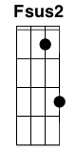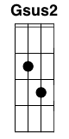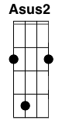

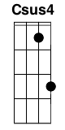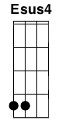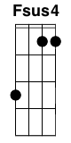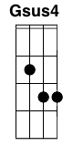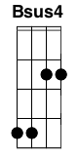

9

 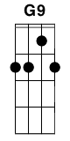 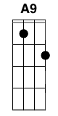

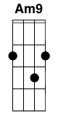

5

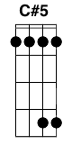 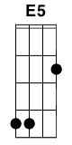 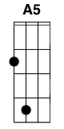 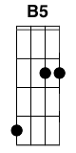

6

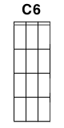 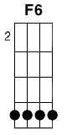 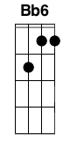

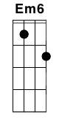 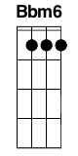

Misc

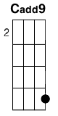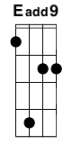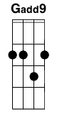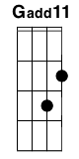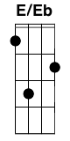****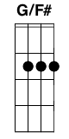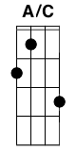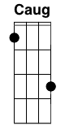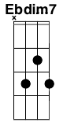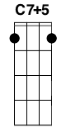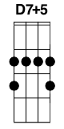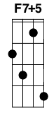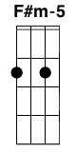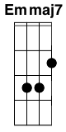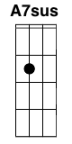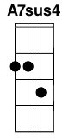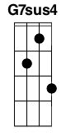

Variations

